**Pseudocode (Algorithm):**

The pseudocode provided below shows how the program will operate.

1. **Start**
2. Display welcome message
3. Display menu
4. Get input from user
5. If input = 1:

Print statistics

Goto 3

If input = 2:

Get filename from user

Write detail of children with no teeth loss to file with name provided by user

Goto 3

If input =3:

Display graph to show total number of children in each state

Goto 3

If input = 4:

Get input for first state name

Get input for second state name

Show graph to show average number of teeth loss for these states

Goto 3

If input =5:

Exit program

If input = other value:

Print invalid input

Goto 3

1. **Stop**

**Test Cases:**

Test cases are used to ensure that the program operates correctly.

Five test cases for our program are given in table below:

|  |  |  |  |  |
| --- | --- | --- | --- | --- |
| **Test Case No.** | **Test Steps** | **Expected Result** | **Actual Result** | **Status** |
| 1. | Enter your choice  [1-5]: 1 (1 is entered) | Prints all the statistics as given in appendix of assignment | Prints all the statistics as required | Pass |
| 2. | Enter your choice  [1-5]: 2 (2 is entered) | Ask user to enter new file name and write details of those children who never lost any teeth to this new file | Details of the 17 children is written to the new file with the name provided by user. | Pass |
| 3. | Enter your choice  [1-5]: 3 (3 is entered) | Compare number of children per state in bar chart | A bar chart appears to show the number of children in each state. | Pass |
| 4. | Enter your choice  [1-5]: 4 (4 is entered) | Ask user to enter first state name and second state name and then compare the average number of teeth claim for these states in bar chart | User provides name of two states and the average number of teeth claim for these two states are displayed on bar chart | Pass |
| 5. | Enter your choice  [1-5]: 8 (8 is entered) | Display invalid input message | Displays invalid input and reshow the menu to enter user’s choice. | Pass |

**Demonstration of Test cases:**

To demonstrate the test cases, I run the program to test each test cases. Each test passed the case as the actual result is same as the expected result.

For each test case, actual result is displayed as in figures below:

Figure: Actual Result of Test case no. 1

Figure: Actual Result of Test case no. 2 (details are written to the file with name provided by user (right image))

Figure: Actual output of test case 3

Figure: Actual result of test case 4

Figure: Actual result of test case 5

**Flowchart:**

The flowchart below represents the working steps of the program.

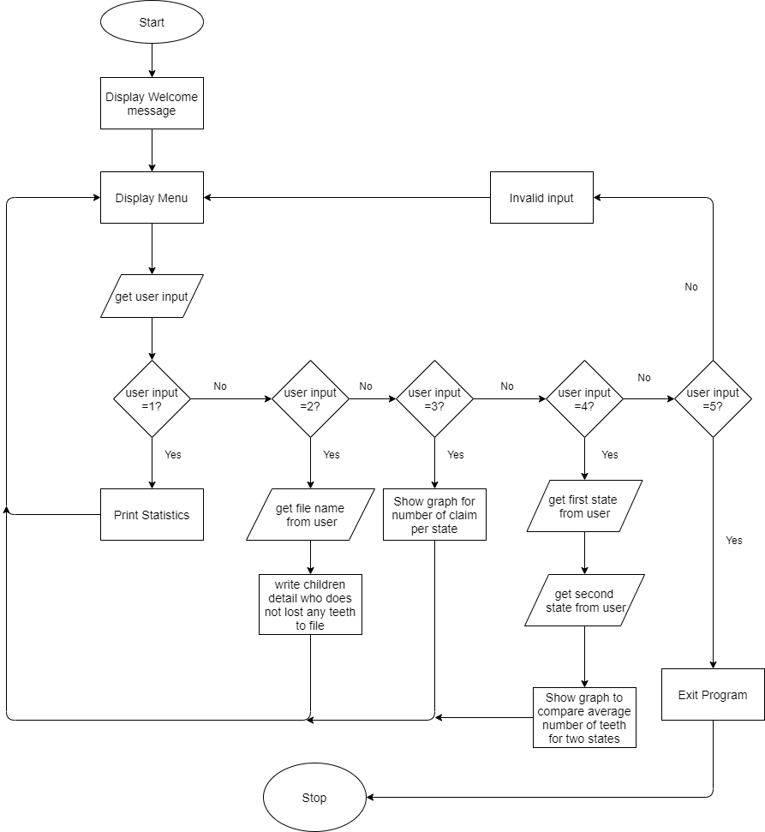

Figure: Flowchart to show the functionality of the program